**Approved**

**by the Resolution of the Management Board of “BCC INVEST” JSC - subsidiary organization of “Bank CenterCredit” JSC No.03/02 dated March 02, 2020, subject to amendments**

**and additions No.03/01 dated March 01, 2021**

**REGULATIONS FOR THE PROVISION OF ELECTRONIC SERVICES**

**“BCC-INVEST” JSC - subsidiary organization of “Bank CenterCredit” JSC**

**Almaty city, 2021**

1

**Table of Contents**

**Terms and Definitions...........................................................................................................................** 3-4

**Chapter 1: General Provisions.............................................................................................................** 4-5

**Chapter 2: Terms and Procedure of the Provision of Electronic Services........................................**5-7

**Chapter 3. Blocking/Unblocking the Customer Account....................................................................**7

**Chapter 4. Security Procedures............................................................................................................**7-9

Appendix 1: Instructions for working in the Personal Profile…………………………………………10-37

2

**TERMS AND DEFINITIONS**

1. For the purposes of the Regulations, the following terms and definitions shall be used:

1) The authentication means confirmation of the Customer's identity and authorization, authenticity and correctness of the electronic document by using the security procedures established by the Broker;

2) The Company means “BCC-INVEST” Joint Stock Company **-** subsidiary organization of “Bank CenterCredit” JSC;

3) The single-use (one-time) code means a unique sequence of electronic digital symbols created by hardware and software at the request of the Customer and intended for one-time use, when providing access to the Company's electronic services to the Customer;

4) The reusable code means a unique sequence of electronic digital symbols created by hardware and software at the Customer's request and intended for multiple use within a certain period of time, when providing the Customer with access to the Company's electronic services;

5) The Company's internal regulations mean procedures, regulations and other regulatory documents governing the provision of services on the securities market, the procedure for working with the Company's Personal Profile and trading platform and the provision of electronic services;

6) The Customer means a natural person or legal entity that has concluded with the Company a Contract/an Agreement on provision of electronic services, which is an integral part of the Brokerage and Nominee Services Agreement, containing the terms and procedure for provision of electronic services;

7) The dynamic customer identification means a procedure for establishing customer authenticity in order to unambiguously confirm his/her rights to receive electronic services by using a single-use (one-time) or multiple-use code;

8) The Customer's instruction means an order (command) and (or) order (request) of the Customer, as well as other instruction of the Customer sent to the Company for provision of electronic services, drawn up in the form of an electronic document or other electronic digital form, certified by means of dynamic identification of the Customer;

9) The security procedure means a set of organizational measures and software and hardware information protection means designed to identify the Customer, when making, transmitting and receiving his/her instructions in order to establish his/her right to receive electronic services and to detect errors and (or) changes in the content of transmitted and received Customer instructions;

10) The trading system of a stock exchange means a set of material and technical facilities, internal documents of a stock exchange and other necessary assets and procedures, which are used to conclude transactions in equity securities and other financial instruments between members of a given stock exchange;

11) The trading platform of the Company means a set of software and technical means of the Company, including information systems, providing information on operations with financial instruments in the trading system of a stock exchange and (or) on the international securities market, on foreign currency operations (in terms of organization of exchange operations with non-cash foreign currency) in the trading system of a stock exchange, the Customer's securities portfolio and other financial instruments of the Customer, other information, as well as provision of electronic information to the Customer;

12) The partners providing access to the Company's trading platform (partners) mean legal entities with whom the Company has entered into a relevant written agreement on exchange of confidential information in information systems and (or) remote service systems of these legal entities providing access to the Company's trading platform and with whom the Customer has entered into a relevant agreement on the use of their information systems and (or) remote service systems. The list of partners is posted on the Company's corporate Internet resource [www.bcc-invest.kz](http://www.bcc-invest.kz/);

13) The Personal Profile - an interactive service in the Company's trading platform placed on the web-site <https://bcctrade.kz>, or on the web-site of the partner providing access to the Company's trading platform, as well as mobile platforms of the Company placed on behalf of the Company or on behalf of the partner providing access to the Company's trading platform in App Store and Google Play through which customers transfer instructions, including with the use of electronic digital signature, receive the necessary information about their personal account, the status of their portfolio, information on financial instruments and their prices, on the course and results of trading on the stock exchange and (or) on the international securities market, reports and histories of their own transactions and other information provided for by the Company's trading platform services;

3

14) The trade operation means an operation performed by the Company in accordance with the Customer's instruction (order (command) and/or order (request)) on:

• purchase or sale of a financial instrument through a trading platform in the trading system of a stock exchange and (or) on the international securities market, including repo transactions;

• debiting (crediting) money from (to) the customer's account and its conversion;

15) The operation on the personal account means operation on:

• opening a personal account for a natural person;

• change of the Customer information;

• debiting (crediting) securities from (to) the Customer's accounts (account);

• write-off (crediting) of claim rights under the issuer's obligations under equity securities from (to) the Customer's personal account(s);

• encumbrance of securities (rights of claim under the issuer's obligations under equity securities) and removal of the encumbrance;

• crediting monetary funds from the redemption of securities;

• crediting dividends on securities.

16) The information operation means operation by:

• issuance of a statement from the Customer's personal account;

• issuance of a report of transactions;

• preparation and issuance of other reports as requested by the Customer.

17) The electronic services mean services provided by the Company to the Customer through the Company's trading platform to carry out trading operations, operations on Personal Profile and (or) information operations, as well as other services provided by the Company in accordance with the legislation of the Republic of Kazakhstan on the securities market, internal regulations of the Company and concluded agreements with the Customer;

18) The electronic digital signature (EDS) means a requisite of an electronic document intended to protect an electronic document, obtained as a result of cryptographic transformation of information using a private key of an electronic digital signature and allowing to identify the owner of a signature key certificate, as well as to establish the absence of distortion of information in an electronic document;

19) The Customer authentication means are the identifier (user name), reusable and single-use (one-time) Customer codes, biometric identification of the Customer, as well as the electronic digital signature of the Customer;

20) The sms (Short Message Service) means a technology that allows receiving and transmitting short text messages designed for prompt transmission of a single-use (one-time) code of the Customer to the registered mobile (cellular) phone number specified by the Customer;

21) The Customer's authorized person means a person, who has the right to sign the Customer's instructions and is authorized to perform operations under the Agreement;

22) The electronic document means a document in which information is presented in electronic digital form and complies with the established format;

23) The Electronic Document Management (EDM) means exchange of electronic documents in the Personal Profile in accordance with the Agreement;

24) The confidential information - personal data, commercial and other confidential information about the Customer, as well as other information protected by the legislation of the Republic of Kazakhstan, subject to protection from illegal collection, storage, use, distribution, provided that this information has actual or potential value by virtue of its unknown to third parties, there is no free access to it on a legal basis and the holder of this information takes measures to protect its confidentiality, made on paper medium, in electronic or other form;

4

**25)** **Terms and designations not expressly defined in this section shall be used in the meanings established by the legislation of the Republic of Kazakhstan, internal regulatory documents of the Company, regulations of the stock exchange and the Agreement on rendering brokerage and nominal holding services.**

**CHAPTER 1. GENERAL PROVISIONS**

* 1. These Regulations for the provision of electronic services of “BCC-INVEST” JSC **-** subsidiary organization of “Bank CenterCredit” JSC (hereinafter referred to as the “Regulations”) are developed in accordance with:

• Law of the Republic of Kazakhstan “On Securities Market” (hereinafter referred to as the “Securities Market Law”) No.461-II dated July 02, 2003;

• Resolution of the Management Board of the National Bank of the Republic of Kazakhstan “On Approval of the Regulations of Brokerage and (or) Dealer Activities in the Securities Market, Procedure of Broker and (or) Dealer Banking Operations” (hereinafter referred to as the “Resolution No.9”) No.9 dated February 3, 2014;

• Resolution of the Management Board of the National Bank of the Republic of Kazakhstan “On Approval of the Instruction to software and hardware and other equipment necessary for carrying out activities on the securities market” (hereinafter referred to as the “Resolution No.165”) No.165 dated April 28, 2012.

• Resolution of the Management Board of the National Bank of the Republic of Kazakhstan “On Approval of the Regulations for the provision of electronic services by Nominal Holders” (hereinafter referred to as the “Resolution No.27”) No.27 dated January 28, 2016;

• The Company's internal documents regulating the provision of services on the Company's securities market.

1.2. The Regulations establish the peculiarities of provision of electronic services by the Company, containing the procedure and conditions of provision (suspension, termination and resumption of provision) of electronic services, description of security procedures, organizational measures and software and hardware means ensuring information security during provision of electronic services by the Company.

**CHAPTER 2. TERMS AND PROCEDURE OF THE PROVISION OF ELECTRONIC SERVICES**

2.1. Electronic services are provided by the Company to the Customer through the Customer's Personal Profile in the Company's trading platform integrated with the trading system of the stock exchange and (or) other trading (information) system for conclusion of transactions on the securities market of the Republic of Kazakhstan and (or) international securities market.

2.2. The Company's trading platform provides electronic services for:

1) trading operations, personal account operations, information operations and other services, including but not limited to the following operations;

• formation of customer orders, when carrying out a trade operation;

• generation of reports on the fulfillment of customer orders;

• generation of customer orders;

• generation of a statement from the Customer's personal account;

• generation of reports on performed transactions and other reports at the Customer's request;

• generation of reports on the history of visits and transactions;

• opening a personal account;

• debiting (crediting) securities from (to) the Customer's accounts (account);

5

• encumbrance of securities (rights of claim under the issuer's obligations under equity securities) and removal of encumbrance.

• purchase or sale of a financial instrument, in the trading system of a stock exchange and (or) in the international securities market, including repo transactions;

• debiting (crediting) money from (to) the Customer's accounts (account); • monetary funds conversion;

• crediting of monetary funds from redemption of securities;

• crediting of dividends on securities.

2.3. The trading platform provides the following administrative and control functions on:

• formation of refusal to execute the Customer's instruction in cases stipulated by the legislation of the Republic of Kazakhstan on the securities market;

• preservation of changed data and the Customer search, including by previous data;

• preservation of information on all trading operations, operations on the personal account and (or) information operations for the whole period in case of change of last name, first name, patronymic (if any) or full name of the Company's Customer;

• searching for information on a natural person request;

• control over the completeness of the data entered and their compliance with legal requirements; • support for the state language and other languages;

• submitting instructions and orders (commands) to change the Customer details, phone numbers:

• notification to the Customer's e-mail account;

• functioning of the Company's trading platform through secure channels using data encryption algorithms;

• saving user's settings and preferences, when working in the Personal Profile;

• any criteria with saving the request, as well as sorting information by any parameters and the ability to view information for previous dates;

• processing and storage of information on all the operations by dates without abbreviations;

• other functions.

2.4. Login to the Personal Profile is carried out by the Customer through personal and (or) tablet computers and (or) cellular phones and other supported devices using special applications (programs) that do not contradict the legislation of the Republic of Kazakhstan.

2.5. To enter the Personal Profile, the Customer uses the means of authentication provided for by the Company's internal regulations and the Agreement/and/or Contract.

2.6. Provision of electronic services to the Customer is possible subject to conclusion of the Brokerage and Nominee Services Agreement (hereinafter referred to as the “Brokerage Agreement”), which provides for the possibility of rendering electronic services, registration as a user and creation of the Customer's account.

2.7. Access to the Personal Profile and the Company's trading platform and basic security procedures:

1) Login to the Personal Profile in the Company's trading platform is performed using authentication by multiple-use password and/or with the use of EDS, as well as user login;

2) Login and temporary password are generated in the Company's software (hereinafter referred to as the “Automated Information System”) and are provided to the Customer in a sealed envelope received by the Customer upon signing the Agreement;

3) The temporary password generated by the Automated Information System is subject to mandatory replacement with the Customer's password entered by the Customer. The Customer is automatically redirected to the password change page, when authorizing with a temporary password.

6

4) To obtain EDS and generate a password, it is necessary to pass the activation procedure in accordance with the Personal Profile User's Manual, which is an integral part of these Regulations, given in Appendix 1 (hereinafter referred to as the “Manual”).

5) The password created by the Customer is the confidential information and is stored in the Automated Information System in encrypted form. The Company's employees do not have access to the Customer's password, and in case of the need to recover the password in case of its loss, it shall be canceled with the subsequent provision of a new temporary password to the Customer.

6) The user authentication is carried out in the mode of high security login and password over a secure https channel.

7) If the user is not active in the Personal Profile for a long time, access to it is blocked. It is required to log in to the Personal Profile again, a “repeated” user identification process takes place, excluding unauthorized access;

8) In order to minimize unauthorized access to the Personal Profile, the instructions transmitted from the Customer to the server and back information generated by the Company are transmitted in encrypted form.

9) Basic security procedures and the procedure of granting access to the Personal Profile and trading platform of the Company through information systems and (or) remote service systems of partners are determined by paragraph 4.8. of the Regulations.

2.8. The Customer's Personal Profile is integrated with the Company's trading platform, which in turn is integrated with the Automated Information System, stock exchange trading system, information resources, central depository, international exchanges and other external information providers, as well as with information systems of partners providing access to the Company's trading platform.

The integration provides real-time information on transactions with financial instruments in the stock exchange's trading system, displayed automatically in the Customer's Personal Profile.

2.9. For sending instructions (trading operations) and other operations, except for the operations specified in paragraph 2.10 of these Regulations the use of dynamic identification of the Customer with the use of single-use (one-time) or EDS is provided, thus the Customer assumes responsibility for the chosen method of dynamic identification and protection of information. In order to improve security and reduce the risks of unauthorized operations, the Company has the right to limit trading operations of the Customer without using EDS on the maximum amount and (or) type of operation.

2.10 The Company is not responsible for any technical problems (termination of work and/or failures) in the Personal Profile and (or) the Trading Platform.

2.11. In cases, when the transfer of the Customer's instructions, electronic documents and execution of transactions by the Customer via the Personal Profile and (or) the Trading Platform is impossible, in accordance with the Brokerage Agreement the Customer is entitled to use any of the other methods of transferring the Customer's instructions to the Company.

2.12. Access to electronic services is provided by authentication of the Customer - the Personal Profile user by one and (or) simultaneously by several methods:

2.12.1. Password Authentication:

• Authentication by reusable codes (password) - is performed for logging in, information operations and certain types of trading operations.

• Authentication by single-use (one-time) codes - is performed for all the types of trade operations.

2.12.2. On the Customer's mobile devices, as well as when using information systems and (or) remote service systems of Partners for providing access to the Company's trading platform, it is possible to set up alternative means of authentication of the Customer, when accessing the Personal Profile, such as biometric identification, pin code or other means, including one-time codes sent to the Customer's mobile number, allowing to uniquely identify the Customer. In this case, the Customer entrusts the storage and transfer of his/her means of authentication to a personal device and (or) information systems and (or) remote service systems of Partners to provide access to the Company's Trading Platform and the built-in methods of authentication, encryption and protection of this information from unauthorized access applied in them.

7

2.13. After successful authentication the procedure of dynamic authorization (identification) of the Customer by the corresponding to this Customer - user of the system is performed.

2.14. Each of the abovementioned methods of authentication and dynamic identification of the Customer, as well as their procedure and confirmation of the Customer's rights to receive electronic services are established in accordance with the services of the Trading Platform, the Personal Profile and according to the Regulations.

2.15. If necessary, upon prior written agreement between the Parties and/or in cases expressly provided for by the Brokerage Agreement, the Legislation, to ensure the performance of transactions on debiting (crediting) securities from (to) the Customer's accounts (account), as well as encumbrance of securities and encumbrance relief) in the Personal Profile, the Customer shall form an EDS. The Customer is entitled to use his/her valid EDS issued by the National Certification Center of the Republic of Kazakhstan.

2.16. In case of necessity of making EDS the Customer has the right to apply to the authorized body for making EDS independently. At that, all the actions on EDS creation shall be performed independently by each of the Customer's authorized persons in accordance with the requirements of the National Certification Center of the Republic of Kazakhstan.

2.17. The Customer shall independently ensure the safety of his/her EDS, identifier/authentication/dynamic identification means, including single-use (one-time) and reusable codes, as well as authorization means configured on the smartphone and (or) personal devices. All the responsibility for the safety of EDS, identifier/authentication means/dynamic identification, including single-use (one-time) and reusable codes, as well as authorization means configured on the smartphone and (or) personal devices, lies with the Customer. All the damages from the use by unauthorized persons of the Customer or third parties as a result of improper storage and/or use of EDS, identifier/authentication/identification means as well as authorization means configured on the smartphone and (or) personal devices are borne by the Customer. At the same time, the Customer is obligated to timely notify the Company about changes in the composition of the Customer's authorized persons to suspend the validity of the relevant certificates and keys/authentication/identification means of the Customer or to obtain new ones.

2.18. The Customer shall independently and at its own expense provide technical and communication resources necessary for the operation of the Personal Profile. The requirements for hardware and software are set out in the Regulations.

2.19. Access to the Internet for connection to the Personal Profile is carried out by the Customer independently through his/her Internet provider.

2.20. The Customer may change the password required for connection to the Personal Profile on his/her own. Password is any sequence of letters of the Latin alphabet and numbers, which is confidential information, the preservation of which is the Customer's personal responsibility.

2.21. Suspension and termination of electronic services.

2.21.1. Unilaterally by the Company by sending to the Customer not less than 3 (three) calendar days' notice through the Personal Profile and/or publishing information on the Company's Internet resource, or in any other way, in the case of:

scheduled and unscheduled preventive maintenance in the Trading Platform, Personal Profile, scheduled technological changes to the Trading Platform and Personal Profile;

obtaining information on the misuse of information obtained by the Customer through the Personal Profile.

2.21.2. Also, in addition to the cases specified in paragraph 2.21.1, the Company has the right to unilaterally suspend the fulfillment of its own obligations to provide electronic services or refuse to fulfill them without notifying the Customer in the case of:

8

existence of grounds for assumptions about unauthorized access of the Customer to the trading platform;

existence of grounds for assumptions about unauthorized or malicious actions of the Customer in the Personal Profile;

failures in the Personal Profile during unscheduled preventive maintenance;

arising disputable claim situations, including in connection with the use or impossibility to use the Personal Profile, the Trading Platform until such disputable situations are resolved, or until the Parties reach an interim agreement;

violation by the Customer of the current or applicable legislation regulating activities on the securities market, violation by the Customer of the Agreement, the Regulations, regulations of the owners of exchange information, as well as in case of technical failures in the software and hardware of the trade organizer, the Company or providers of communication channels.

existence of information about compromise of the identifier or single-use (one-time) and reusable codes and EDS of the Customer. In this case, the Company shall resume fulfillment of obligations to provide electronic services after the Customer receives a new identifier, EDS and single-use (one-time) and reusable codes.

2.21.3. The Company shall suspend provision of electronic services in case of execution of the Trading Operation, Transaction on the personal account on the grounds stipulated by the Agreement, legislation of the Republic of Kazakhstan, including the following conditions:

the number of securities to be debited from the personal account exceeds the number of securities on this account;

the amount of monetary funds on the Customer's account is insufficient to execute a trade operation; the securities to be written off are encumbered and (or) blocked.

2.21.4. In case of occurrence of one of the cases stipulated in sub-paragraph 2.21.3. of the Regulations, the Company's trading platform and (or) the Personal Profile shall issue to the Customer a notice of refusal to perform these operations/transactions.

2.21.5. Termination of provision of electronic services by the Company shall be carried out in accordance with the procedure, on the terms and on the grounds set forth in paragraph 2.21.6. of the Regulations.

2.21.6. If the Customer violates the obligations assumed under the Brokerage Agreement and/or the terms/requirements of the Brokerage Agreement/Regulations with regard to the procedure/conditions/methods of rendering electronic services, the Company shall unilaterally, extrajudicially terminate the provision of electronic services with a prior written notice to the Customer at least 1 (one) business day in advance.

The use of the Personal Profile shall be terminated immediately in case of termination of the Agreement and/or due to its termination.

2.22. Resetting of the password for the Customer to log in to the Personal Profile is carried out on the basis of the Customer's application.

2.23. At the Customer's request, the Company shall provide certified copies of the Customer's instructions received by the Company using the Personal Profile within 5 (five) business days of the Customer's request.

2.24. Notifications to the Customer about significant changes introduced in the Trading Platform, Personal Profile related to the procedure of rendering electronic services and (or) means of identification and authorization of the Customer are carried out (notified to the Customer) by publishing on the corporate Internet resource of the Company and (or) directly in the Personal Profile within one working day from the moment, when these changes come into force.

**CHAPTER 3. BLOCKING/UNBLOCKING THE CUSTOMER ACCOUNT**

3.1. In case of loss of EDS and/or disclosure of means of authentication/dynamic identification to third parties, the Customer should immediately contact the Company by submitting a written application, and in case it is impossible to do so, by e-mail to block the Customer's account in the Company's trading platform.

9

3.2. If an account is blocked in the Company's trading platform, the Customer's access to electronic services will be denied and the provision of electronic services will be unilaterally suspended.

3.3. All customer instructions received by the Company through the Personal Profile before the Company receives the Customer's request to block the account will be considered as the instructions duly authorized by the Customer, even if they are made by fraud and contrary to the terms of any other instructions or orders given by the Customer at any time. The Company is not responsible for the authenticity of the Customer's instructions and/or the customer's authorization to submit the instruction, nor for the Customer's failure to timely apply to block the account.

3.4. Unblocking of the Customer's account in the Company's trading platform, including in case of blocking of the Customer's account due to incorrect typing of the password more than nine times, is made on the basis of the Customer's application sent to the Company's e-mail address in an arbitrary form.

3.5. When all the accounts in the Company are closed, the account is canceled at the same time as all the accounts are closed.

**CHAPTER 4. SECURITY PROCEDURES**

4.1. Security procedures allow to reliably identify the Сustomer and his/her right to receive electronic services, to detect the presence of distortions and/or changes in the content of electronic documents on the basis of which electronic services are provided to the Сustomer, to protect against unauthorized access to information constituting a trade secret and to ensure the integrity of this information.

4.2. Security procedures include:

1) reliable authentication of the Сustomer (login and operations in the Personal Profile are performed by login and password, as well as in cases provided by means of EDS);

2) control over completeness of the entered data. In case of performing functions or operations without completely filling in all the fields in the Personal Profile, a corresponding notification is issued;

3) protection against unauthorized access to information constituting a trade secret on the securities market and the Customer's personal data is carried out by encrypting received and transmitted data using https protocols, RSA, SHA and similar encryption procedures;

4) ensuring by the Company's trading platform the integrity and safety of information in electronic archives and databases in case of: complete or partial power failure in any part of the software at any time; failure of networks, telecommunications, breakdown of established physical and virtual connections. Information security is ensured, among other things, by periodically saving a backup copy of the database and system transaction log on an additional server, mirror and physically remote storages;

5) blocking by the Automated Information System of unauthorized access to the Company's trading platform and the Сustomer's Personal Profile;

4.3. Information protection procedures are performed both on the Сustomer's personal computers, mobile devices, and on the Internet, and on the Company's servers and information systems and (or) remote service systems of partners providing access to the Company's trading platform.

4.4. In order to authenticate the Customer, when accessing Personal Profile and providing electronic services, the Company's trading platform provides the following identifying data - login and temporary password during initial registration, login and password during subsequent access. Additional protection is provided by means of EDS procedures or by means of one-time codes sent to the Customer's mobile number. On mobile devices of the Customer, as well as when using information systems and (or) remote service systems of partners providing access to the trading platform of the Company, it is possible to set up alternative means of authentication of the Customer, when accessing the Personal Profile, such as biometric identification, pin-code or other means, including one-time codes sent to the mobile number of the Customer, allowing unambiguous identification of the Customer. In this case, the Customer trusts the storage and transfer of his/her means of authentication to a personal device and (or) information systems and (or) remote service systems of partners for providing access to the trading platform of the Company and the built-in methods of authentication, encryption and protection of this information from unauthorized access applied in them.

10

4.5. After the initial login to the Personal Profile the Customer is obligated to change the password. All the types of trading operations are prohibited in the Company's trading platform until the user changes the temporary (primary) password.

4.6. Subsequent access to the Personal Profile, authentication, provision of electronic services, execution of the Customer's instructions for which the use of EDS is not required, is made on the basis of login, password specified by the Customer himself/herself during the initial registration (or when changing the account). In established cases electronic services for trading operations may be provided by means of a one-time password.

4.7. In case of repeated (more than nine times in a row) incorrect entering by the Customer of the password for access to the Personal Profile, as well as for receiving electronic services, the Customer's account in the trading platform of the Company is automatically blocked unilaterally.

4.8. Security procedures, when rendering electronic services with the use by the Customer of information systems and (or) remote service systems of partners intended for access to the Company's trading platform:

4.8.1. exchange of information between the Company and the partner on granting access to the Company's trading platform is carried out through secure communication channels with the use of encryption;

4.8.2. control over completeness of entered data is ensured by issuing an appropriate notification in case of performing functions or operations without completing all fields completely;

4.8.3. authentication of the Customer by the Company is made on the basis of the Customer's data received by the partner during the authentication of the Customer in the information system and (or) remote service system of the partner and transferred by the partner to the Company as the data of the Customer, who has passed the proper authentication and details specified in the technical descriptions of the system operation;

4.8.4. for sending instructions and performing other operations, except for operations specified in paragraph 2.10 of these Regulations, the use of dynamic identification of the Customer using a single-use (one-time) password or EDS is provided. In order to improve security and reduce the risks of unauthorized operations, the Company has the right to limit trading operations of the Customer without using EDS on the maximum amount and (or) type of operation;

4.8.5. to provide access to the trading platform through information systems and (or) remote service systems of partners, the Customer sends through information systems and (or) remote service systems of partners a corresponding request. If the request has successfully passed the authorization check, the Customer is considered to be successfully authenticated through the information system and (or) remote service system of the partner and can use electronic services of the Company through information systems and (or) remote service systems of the partner;

4.8.6. ensuring the integrity and complete safety of information in electronic archives and databases in the event of complete or partial power failure at any time at any part of the software and failure of networks, telecommunications, breakdown of established physical and virtual connections is performed by periodically saving a backup copy of the database and system transaction log on an additional server of the Company.

4.9. The Customer, except for the cases of entering information in the Personal Profile, shall not disclose, provide any third parties (including employees of the Company) with his/her login, password and one-time (reusable) passwords sent to the Customer's mobile number.

4.10. The provision of electronic services is subject to the Customer's compliance with security procedures.

4.11. In case of detection of unauthorized access or suspicion of unauthorized access to the Personal Profile, the Customer shall notify the Company not later than the next working day after the day of their detection. The notification is made in writing in any form or by means of e-mail of the Customer specified in the questionnaire. The Company suspends the provision of services until the circumstances are fully clarified, and further instructions sent by the Customer through the Personal Profile will be accepted by the Company after the procedure of deactivation of the compromised Customer's account and receipt by the Customer of new identification data (login and temporary password). The Company is not responsible for late notification (failure to notify) and the Customer shall bear the risk of losses incurred as a result of his/her untimely application on his/her own.

11

4.12. Upon detection of unauthorized access to information constituting a trade secret on the securities market and the Customer's personal data, their unauthorized modification, unauthorized trading operations, operations on the personal account and information operations arising from the provision of electronic services, the Company shall notify the Customer thereof not later than the next business day after the day of their detection.

4.13. It is not allowed in the Company's trading platform:

− maintenance of means to perform certain functions and operations in violation of the established procedure for their performance;

− availability of functions that allow you to directly make changes to already generated output reports;

− change (deletion) of data on performed operations and the state of personal accounts, except for operations (functions) specially designed for this purpose;

− formatting (changing) output forms, including the Customer’s order (request), the Customer's order (command), report on the Customer's transactions, the Customer's personal account statement.

4.14. When obtaining electronic services:

4.14.1. The Customer is not allowed to disclose, and/or reproduce, and/or distribute partially or fully to third parties any information related to the operation of the Personal Profile, the Trading Platform and being a trade secret, as well as any other information (unless the Customer is authorized by the Company to disclose, and/or reproduce, and/or distribute this information), which becomes available to them due to the operation of the Personal Profile and the Trading Platform.

4.14.2. The Customer shall ensure an appropriate level of protection of his/her software and hardware devices (personal computer, smartphone, software installed on them and other information systems), preventing further distribution of information obtained through the Personal Profile and the Trading Platform by third parties.

4.14.3. The Customer excludes the possibility of third parties accessing his/her cellular phone, smartphone, personal computer and any means of authentication/identification.

4.14.4. The Customer ensures regular preventive maintenance, anti-virus scanning and protection of his/her software and hardware devices (personal computer, smartphone, software installed on them and other information systems).

4.14.5. If necessary, the Company will be contacted by other means of communication and in case of malfunctions of the Personal Profile.

4.14.6. In case of damage to the Company as a result of non-compliance by the user of mandatory conditions for confidentiality and non-disclosure of information, the Customer shall be obligated to compensate in full the direct damage to the Company, as well as bear other responsibility in accordance with the current legislation of the Republic of Kazakhstan.

4.14.7. It is not permitted for the Customer to take actions aimed at:

obtaining information from the Personal Profile not belonging and not directly related to the Customer, except for directly provided information on the course of trading of trade organizers, analytical reviews and other information from information agencies;

connection to the Personal Profile either by using someone else's ID or by using a method of selecting someone else's ID and key;

using available technical means to penetrate the Company's local networks;

any other actions that create prerequisites for failures in the operation of individual subsystems and/or the Personal Profile as a whole.

4.15. The Customer's failure to fulfill the security procedures and requirements listed in paragraph 4.14 of these Regulations is an unconditional ground for suspension or termination of the Customer's access to the trading platform using the Personal Profile.

4.16. In case of detection of connection to the Personal Profile without the Customer's consent, as well as in other cases stipulated by the Brokerage Agreement, the Regulations, the Customer shall immediately send a notice to the Company in one of the following ways:

by contacting the Company's customer support service, with recording of telephone conversations; by submitting to the Company a written application on paper in any form (in accordance with the established mode of operation of the Company)

by sending a notice to the Company electronically to the following e-mail address: [info@bcc-invest.kz](mailto:info@bcc-invest.kz)

12

**CHAPTER 5. BASIC TERMS AND CONDITIONS (PROVISIONS), PROCEDURE AND METHODS OF RESOLVING CONFLICT SITUATIONS ARISING FROM THE PROVISION OF ELECTRONIC SERVICES BY THE COMPANY.**

5.1. If an instruction is submitted by the Customer using the Customer's authentication/identification means, all the instructions submitted using these authentication means shall mean that the Customer recognizes the fact of submitting these instructions on his/her behalf. The fact of submitting an instruction using the Customer's authentication/identification means is a sufficient basis for carrying out a transaction, and the transactions/operations carried out on the basis of such instructions are recognized by the Customer as having been carried out on his/her behalf.

5.2. The instructions transferred by the Customer to the Company via the Personal Profile and received by the Company, i.e. the verification of identification/authentication means of which gave a positive result, shall have legal force equal to that of equivalent in meaning and content documents drawn up on paper media and signed by the handwritten signature of the same Customer or his/her authorized person and (for legal entities) certified by the imprint of the Customer's seal.

5.3. The time of acceptance of an electronic document/instruction for execution by the Company is the time of registration of this electronic document/instruction on the Company's server according to the system clock of the server from the moment of acceptance of the electronic document/ instruction for processing. In this case, the Customer's instructions/documents are accepted for execution from the moment of their registration, according to the Company's operating day schedule published on the Company's corporate Internet resource and (or) in the Personal Profile. The Customer's instructions received after the specified term are subject to execution by the date of the next operational day.

5.4. In case of malfunction of the Customer's remote workplace and (or) the Trading Platform during trading, all the Customer's instructions previously transferred in the Personal Profile remain active. In case of malfunction of the remote workplace, the Customer shall promptly contact the Company to make a joint decision on the Customer's instructions left in the Trading platform through the Personal Profile.

5.5. Confirmation of sending and/or receipt of an electronic document/instruction is carried out electronically within the Trading Platform. Accounting (registration) of received and/or executed electronic documents/instructions is carried out by the Company in the electronic logbook of the Trading Platform.

5.6. As a proof of the fact of transactions under the Brokerage Agreement, when receiving electronic services, an electronic log of accepted and executed electronic documents in the Personal Profile, as well as electronic reports and official notifications sent to the Customer.

5.7. An electronic document gives rise to obligations of the Customer and the Company under the Brokerage Agreement, if the electronic document is duly executed, successfully authenticated, certified by EDS or confirmed by a one-time (one-time) code, transmitted from the Personal Profile, and executed by the receiving party.

5.8. In case of conflict between the Customer and the Company arising in the course of provision of electronic services, the Customer may initiate a reconciliation of instructions submitted by the Customer, received electronic documents with the data in the Company's accounting system. In case of discrepancy between the information in the Personal Profile and in the Company's accounting system, the information in the Company's accounting system shall prevail.

5.9. The Company shall make all reasonable efforts to ensure smooth and error-free operation of the Trading Platform and the Personal Profile. The Personal Profile is provided to the Customer for use on an “As Is” and “As Available” basis. Without the Company's guarantee of error-free and uninterrupted operation of the Trading Platform and the Personal Profile and the Company's reimbursement of any direct and indirect losses resulting from the use (inability to use) of electronic services.

5.10. In case of detection of technical failures, erroneous operation, delay in presentation of information, the Customer has the right to apply to the Company's technical support service for elimination of defects in the trading platform operation.

13

5.11. All the disagreements, conflict situations arising between the Parties under the Brokerage Agreement during provision of electronic services shall be resolved through negotiations, and in case of failure to reach an agreement, the Parties shall have the right to appeal to the court in the manner prescribed by the legislation of the Republic of Kazakhstan.

14

Appendix 1

**Personal Profile User Manual**

**Language support**

In the web version of the Personal Profile bcctrade.kz you can switch from the Russian interface to English, Kazakh, and vice versa by clicking the appropriate shortcut in the upper left part of the menu.

The interface languages of the Personal Profile, when using information systems and (or) remote service systems of partners providing access to the Company's trading platform and applications for smartphones may not support language switching.

All the illustrations are examples for the web version of the Personal Profile bcctrade.kz, the real appearance of the Personal Profile may differ significantly from the given depending on the services of the Personal Profile, when using information systems and (or) remote service systems of partners to provide access to the trading platform of the Company and applications for smartphones.

**1. HARDWARE AND SOFTWARE REQUIREMENTS.**

To work you need to have access to the Internet and use your own technical equipment in the following configuration:

• A personal computer connected to the Internet;

• Operating system Windows 7 and above, or other operating system with a Java-enabled browser installed;

• Any browser that supports Java (when using EDS);

Most modern operating systems are Java-enabled and there is no need to install additional software.

• Java runtime Environment (when using EDS).

List of certification centers, whose electronic digital signatures are allowed to be used in the System:

• National Certification Center. Smartphone supporting iOS 9.3.5 or higher Smartphone supporting Android 7.0. or higher

Requirements of partners to hardware and software for providing access to the Company's trading platform may differ from the above.

**2. REPORTS**

The Personal Profile displays reports on transactions performed on brokerage accounts under the Brokerage and Nominal Holding Services Agreement concluded between the Customer and the Company (hereinafter referred to as the “Brokerage Agreement” or as referred to in this paragraph).

The data in the reports section are for reference only and cannot be used as official information. Data in the reports are updated daily.

**2.1. Transaction History**

This report shows the history of transactions executed (executed) under the brokerage agreements concluded with the Company.

The report is sorted by the date of the transaction.

15

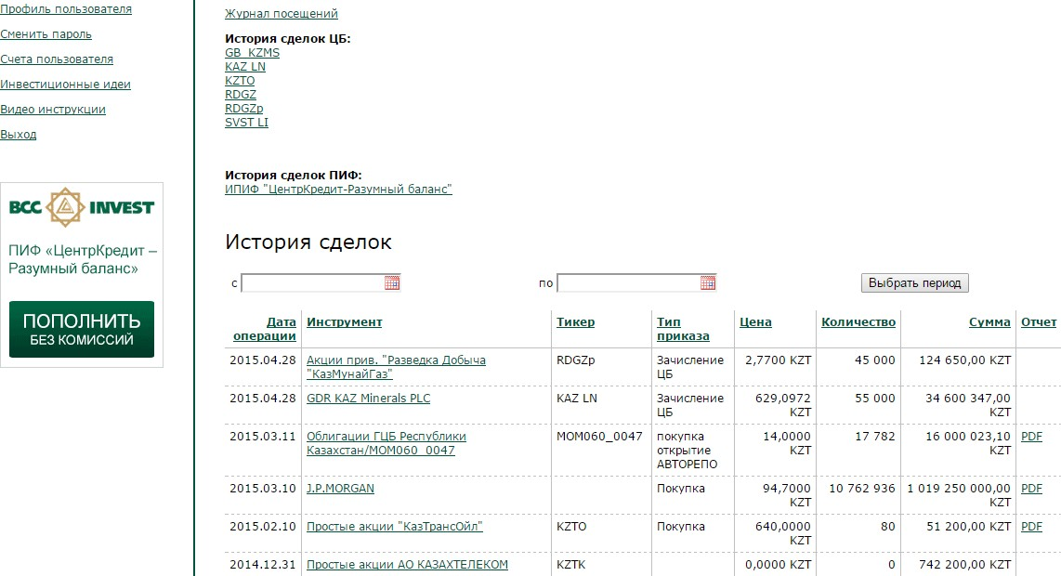

Figure 2. Report on the history of transactions*1 (the graphical example in the Russian language).

This report displays:

• Transaction Date - the date and time of the transaction. The date and time of the transaction may differ from the date and time of the order (command);

• Instrument - name of the security within one information system (KASE, Bloomberg, etc.). In case the security changes the place of storage, one security is written off and the other one is credited, as a rule, with changing the name of the security;

• Ticker is a short name of quoted financial instruments. It is a unique identifier within one stock exchange or information system. Some companies have several different tickers for one security, which are used on different exchanges;

• Order (Command) type - brief name of the order (command) type of this transaction (purchase/sale, debit/charge);

• Price - The price specified in the order (command) (for bonds, the “dirty” price is specified);

• Quantity - The quantity specified in the order (command);

• Amount - the amount of the transaction (Price*Quantity);

• Report - online confirmation of transaction with financial instruments. This report is generated after transaction settlement (purchase/sale of securities; repo).

**2.2. Session history**

This report displays the history of successful user authentications (opening and closing sessions) in the web version of the Personal Profile.

The session history should be reviewed regularly to ensure that there is no unauthorized access to the system.

*1 All graphical examples are given for the web version of the Personal Profile

16

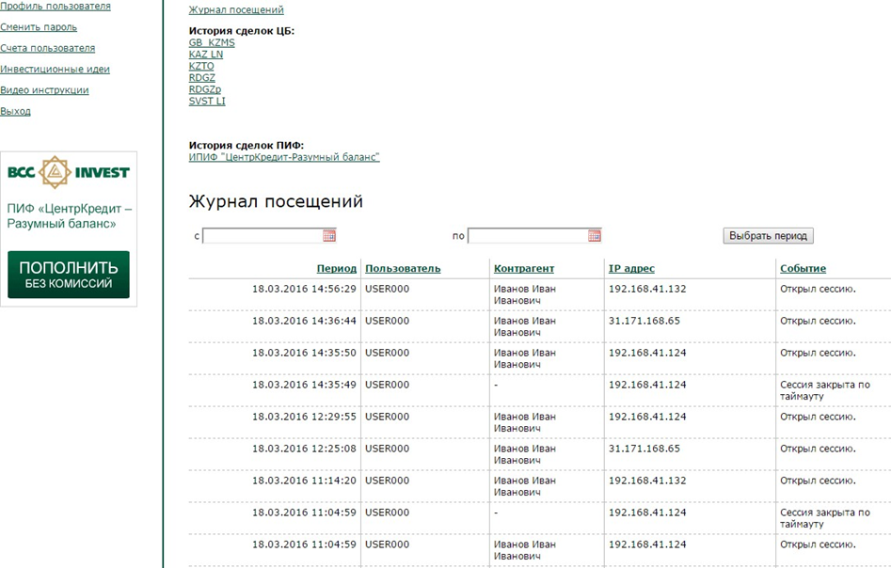

Figure 3. Session history

(the graphical example in the Russian language).

This report displays:

• User - the account name of the user, who logged in to the system (login);

• Counterparty - name of the counterparty to which this account name belongs; • IP address - IP address from which the system was logged in;

• Event - type of event (opening and closing a session, as well as closing a session by timeout); • Period - The date and time of the event.

**2.3. History of securities transactions**

This report can also be generated on the “Current Portfolio” page by clicking on the corresponding value of the financial instrument price in the "Price" column. The report will open on a new page displaying the information on the history of formation of the purchase weighted average price for the selected security.

The data in this section are for reference only and cannot be used as official information. The data in the section is updated daily.

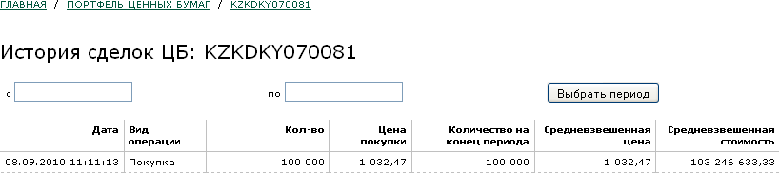

Figure 4. History of securities transactions (the graphical example in the Russian language).

17

This report displays:

• Date - the date of the transaction. The date of the transaction may differ from the date and time of the order (command) acceptance;

• Transaction type - brief name of transaction type of this transaction (purchase/sale, debit/charge). • Quantity - The number of transactions of the selected financial instrument;

• Purchase/sale price - purchase/sale price of the financial instrument (for bonds the “dirty” price is specified);

• Quantity at the end of the period - calculated field (Initial Balance +/- income /expense);

• Weighted average price - calculated field (weighted average cost/quantity at the end of the period);

• Weighted average cost - a calculation field that displays the average purchase price of the purchased securities;

**2.4. History of UIF transactions**

This report can also be generated on the “Current Portfolio” page by clicking on the corresponding price

value in the “Weighted Average Unit Price” column.

The data in this section are for reference only and cannot be used as official information. The data in the section is updated daily.

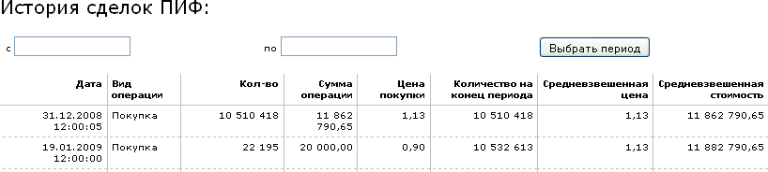

Figure 5. History of UIF transactions (the graphical example in the Russian language).

This report displays the following information:

• Date - the date and time, when the transaction was performed;

• Transaction type - brief name of the transaction type of this trade (purchase/sale). • Quantity - the quantity specified in the application for purchase/sale of units;

• Purchase/sale price - purchase/sale price of a unit;

• Quantity at the end of the period - calculated field about the quantity at the end of the period (Initial balance +/- inflow / outflow);

• Weighted average price - calculated field (weighted average cost/quantity at the end of the period);

• Weighted average cost - a calculated field displaying the average purchase price of the current volume of Units;

**2.5. Transaction history Monetary funds**

18

This report can also be generated on the “Current Portfolio” page by clicking on the amount of monetary funds for the corresponding currency. The report will open on a new page displaying information about the history of monetary funds transactions.

The data in this section are for reference only and cannot be used as official information. The data in the section is updated daily.

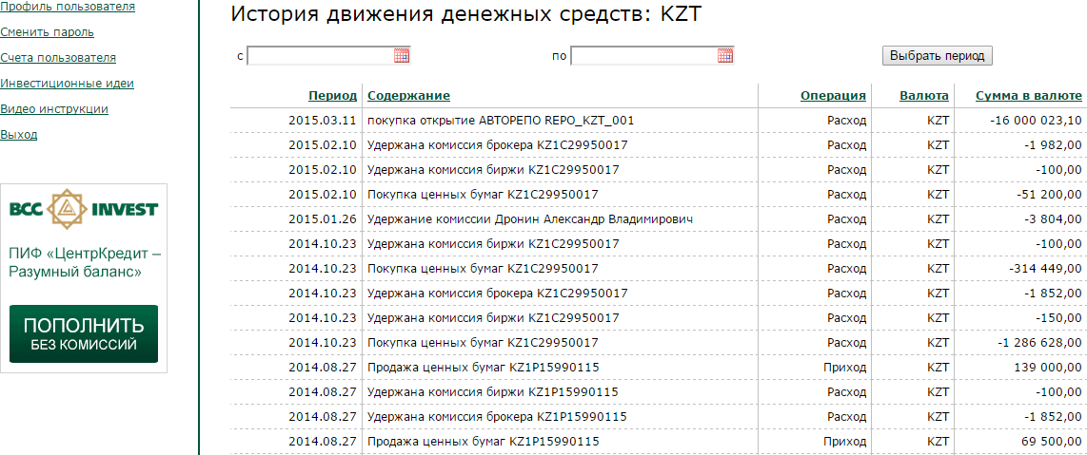

Figure 6. History of transactions monetary funds (the graphical example in the Russian language).

This report displays the following information:

• Period - the date on which the transaction was performed; • Operation - type of transaction (Income/Expense);

• Currency - a type of currency;

• Amount in currency - the amount of the transaction in the currency of the account; • Table of Contents - A brief description of the transaction;

**2.6 Paper report.**

This report displays the information on securities movement (purchase/sale; repo; encumbrance). The report is generated as of the date.

The data in this section is for reference only and cannot be used as official information. The data in the section is updated as the transaction is concluded (purchase/sale; repo; encumbrance).

19

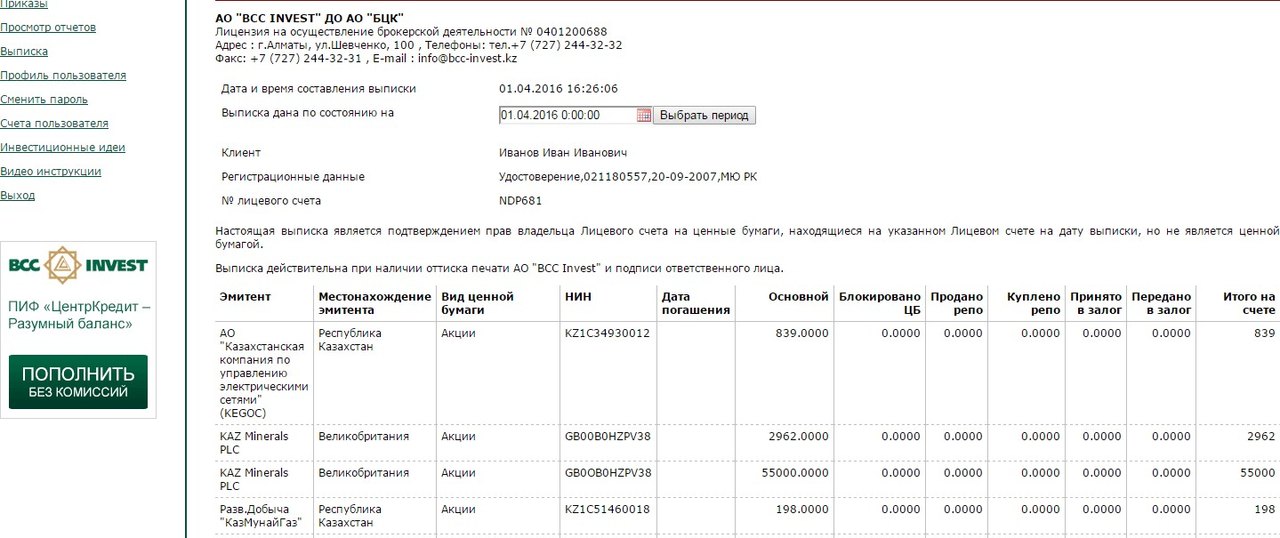

This report displays the following information:

• Issuer - name of the organization that issued the securities;

• Location of the issuer - address of the organization that issued the securities; • Type of securities- classification of securities;

• NIN - national identification number of the securities;

• Securities maturity date - the maturity date of a security, typical for bonds.

• Number of securities free from encumbrance (pieces) - reflection of the number of free securities in the portfolio of the Company's Сustomer;

• Number of blocked securities (pieces) - reflection of the number of securities, which are in the settlements, after conclusion of the transaction (purchase/sale, T+2);

• Quantity sold in REPO (pieces) - reflection of the quantity of securities in the Company's Сustomer's portfolio after conclusion of REPO transaction (Direct REPO);

• Quantity purchased in REPO (pieces) - reflection of the quantity of securities in the Company's customer's portfolio after conclusion of REPO transaction (Reverse REPO);

• Number of pledged securities - reflection of the number of securities pledged after conclusion of the transaction;

• Number of securities pledged (pieces) - reflection of the number of securities pledged after conclusion of the transaction;

• Total securities on the account - reflection of the number of securities after conclusion of transactions at the moment of statement generation.

All the transactions on the Company's Customer's brokerage account are concluded on the basis

of submission of the Customer's signed customer order (request).

**3. CURRENT PORTFOLIO**

This is the main working page of the Personal Profile opened by default. This mode provides monitoring

of the current investment status:

• Securities Portfolio;

• Investments in mutual funds; • Money accounts.

The data in this section is for reference only and cannot be used as the official information.

20

**3.1. Securities**

This section displays the information about your investments in securities, received income/loss since the moment of purchase and current prices within the framework of the Brokerage Agreement concluded with “BCC Invest” JSC.

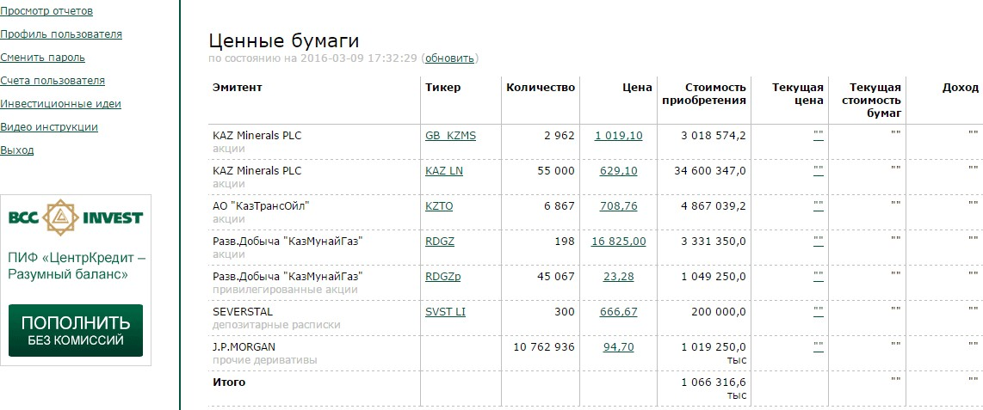

Figure 7. Current securities portfolio

(the graphical example in the Russian language).

The following data is displayed in the Personal Profile:

• Issuer - name of the issuer that issued this security;

• Ticker is a short name of quoted financial instruments. It is a unique identifier within one exchange or information system. The “Ticker” field is a hyperlink to the security value chart (see Section 4.1.1.);

• Quantity - number of securities in your portfolio. Information about the number of securities is updated daily. If the value of the field “Quantity” is more than 1 million, the specified value is rounded. In order to find out the exact quantity, you should click on the hyperlink on the price field (see Section 3.3);

• Price - weighted average purchase price of these securities (purchase price). Field “Price” is a hyperlink to the history of the weighted average price of the security (see Section 3.3);

• Acquisition cost = Quantity*Price. If the value of the field “Acquisition cost” is more than 1 million, the specified value is rounded. In order to find out the exact acquisition cost, you need to click on the hyperlink on the price field (see Section 3.3.);

• Current price is the current price of the security determined by the methodology described below. The “Current Price” field is a hyperlink to the “Market depth” (see Section 4.1.2.) if available. For purposes of this section, the current price is defined as follows:

• a) If there is the information about current bids for purchase/sale (“Market depth”) for a security, the “Current price” field equals the best (maximum) bid of the buyer.

• b) If there is no information on current bids and there is no information on the average price of the last effective day for this security, the field “Current price” is not filled in.

• c) The current price for bonds is not calculated

• Current value of securities = Quantity*Current price.

21

• Income - A field showing absolute (“Current Value” minus “Acquisition Cost”) and relative (“Current Value” – “Acquisition Cost”) income / Acquisition cost) gain/loss from the date of acquisition

The “Market depth” is displayed only for securities for which the Company has the technical capability to display it. The “Market depth” may be displayed with deliberate delay of information set by the provider of such information.

**3.1.1.** **Price chart**

If you click on the corresponding security ticker, a page will open with a graphical display of the price movement history for the selected security, as well as information on transaction volumes (if any).

The price chart is formed only if there is a sufficient amount of information on the quotation of this security. The price chart is formed for securities for which the Company has a technical possibility to display it. The price chart is formed using the Flash technology. To display the chart correctly, the browser should support the Flash technology. In case of problems with displaying charts, it is necessary to enable or install the Adobe Flash Player [(h](http://get.adobe.com/ru/flashplayer/)ttp://get.adobe.com/ru/flashplayer/). Most modern browsers have built-in Flash Player and no additional settings are required.

The data in this section are for reference only and cannot be used as official information. The data in the section is updated daily.

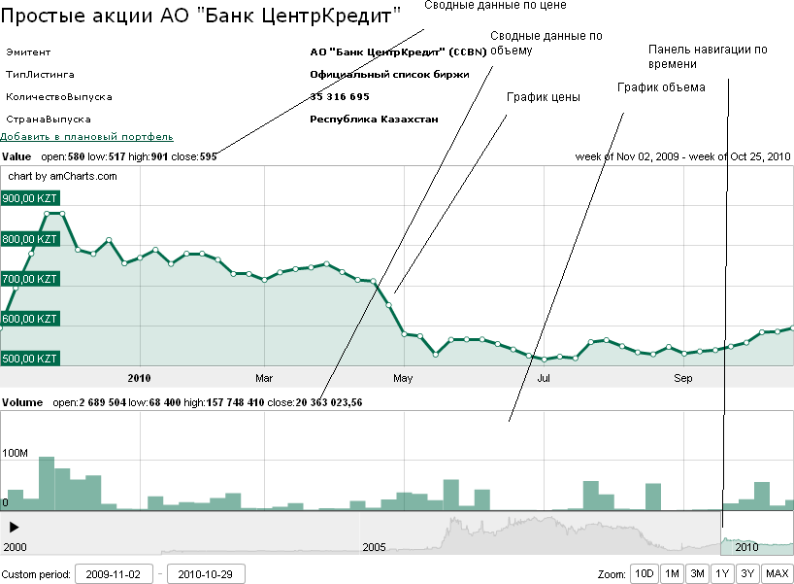

Figure 8. Securities graph (the graphical example in the Russian language).

22

**3.1.2.** **Current buy/sell instructions for “Market depth”**

If you click on the corresponding value of the current price of a financial instrument in the “Current price” column, a page with information about the instructions to buy/sell this financial instrument (if any) will open.

The data in this section is for reference only and cannot be used as official information.

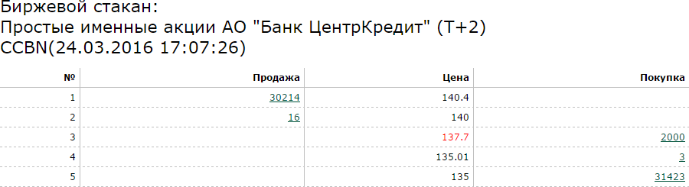

Figure 9. Market depth (the graphical example in the Russian language).

The following data is displayed in the Personal Profile:

• Name of Security.

• Security ticker - code of the selected security (if any). • The date and time the information was last updated;

• A ranked list of buy and sell instructions. The list highlights the best buyer's price, which is used to determine the current market value of the financial instrument;

**3.2. Mutual fund**

This section displays information about your investments in mutual funds of “BCC Invest” JSC, received income/loss since the moment of purchase and current unit prices.

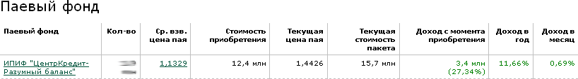

Figure 10. Current UIF portfolio

(the graphical example in the Russian language).

The following data is displayed in the Personal Profile:

• Mutual Fund - the name of the mutual fund;

• Number - current number of units in your portfolio. Information about the number of units is updated daily. If the value of the field “Quantity” is more than 1 million, the specified value is rounded off. In order to find out the exact number, you should click on the hyperlink on the field “Weighted Average Unit Price”;

• Weighted average unit price - weighted average unit purchase price (purchase price). Field “Weighted Average Unit Price” is a hyperlink to the history of the weighted average unit price (see Section 3.4.);

23

• Acquisition cost = Quantity* Weighted average unit price.

In case the value of the field “Acquisition cost” is more than 1 million, then the specified value is rounded up. In order to find out the exact acquisition cost, it is necessary to click on the hyperlink on the “Weighted Average Unit Price” field (see Section 3.4.);

• Current price – the current unit price determined by the accounting data. Information on the current share price is updated daily;

• Current book value = Quantity*Current share price. If the value of the field “Current value of the book” is more than 1 million, the specified value is rounded off. In order to find out the exact cost of purchase, you need to multiply “Quantity” with “Current Unit Price”;

• Earnings Since Acquisition - A field that displays the absolute (“Current Book Value” minus “Acquisition Cost”) and relative (“Current Book Value”)

- “Cost of Acquisition”/Cost of Acquisition) gain/loss since the date of acquisition;

• Income per Year - displays the mutual fund's income for the last 12 calendar months (Current Unit Price / Unit Price 365 days ago);

• Income per month - displays the mutual fund's income for the last 30 calendar days (Current Unit Price / Unit Price 30 days ago);

**3.3. Monetary funds**

This section displays information about your funds on brokerage accounts, within the framework of the Brokerage Agreement, concluded with “BCC Invest” JSC.

Monetary funds position information is updated daily.

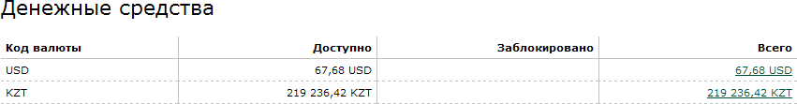

Figure 11. Current Monetary funds portfolio (the graphical example in the Russian language).

The following data is displayed in the Personal Profile:

• Currency code - alphabetic code of the currency in which the money account is opened. • Available - amount of monetary funds available (unencumbered).

• Blocked - amount of blocked (encumbered) funds (within the framework of the decision of the authorized body, repo transactions, unexecuted transaction instructions, transactions concluded under the T+2 settlement scheme)

• Total - Total amount of monetary funds (Available + Blocked). The Weighted Average Unit Price field is a hyperlink to the monetary funds flow history (see Section 3.5.)

**4. ORDERS (COMMANDS)**

In this mode you can create, edit, and view the history of filed orders (commands). The data of this section are of reference nature and cannot be used as the official information. When you start the “Orders (Commands)” section, a new page will be opened, which will show the orders (commands) / orders (requests) submitted by the established method. The amount of information displayed may be limited. The opened window contains the following information about the orders (commands):

24

• Submission date - date and time of order submission, as well as the type of submitted order (command) (Securities/Money/UIF). This field is a reference one, clicking on it will automatically open a window with the parameters of the order (command) you have submitted

• Description - a brief description of the order (command) filed.

• Quantity, Price - displayed for Securities and Pif orders (commands) only, and displays the quantity and purchase/sale price of the security/unit respectively

• Amount - the amount of the transaction specified in the order (command)/order (request).

• Status - current status of order (command)/order (request) processing (Sent to Broker/Processing/Checked/Application Submitted/Executed/Executed/Partially Executed/Not Executed/Broker's Rejection/Customer's Cancellation/Expired)

• Links for signing and deleting the order (command)

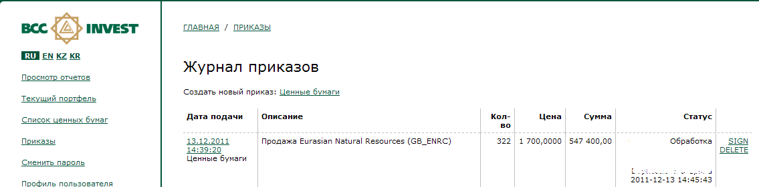

Figure 12. Order book (the graphical example in the Russian language).

For web-version of the Personal Profile bcctrade.kz filling and authorization (signing) of orders (commands) is in 2 stages, at the first stage it is necessary to fill in the order (command) parameters, at the second stage it is necessary to confirm the order (command) with EDS or one-time password. Thus, if it is necessary to separate access rights within one legal entity, you can use EDS file or one-time password on a separate workplace.

In applications for smartphones and in the Personal Profile, when using information systems and (or) remote service systems of partners providing access to the Company's trading platform, authorization (signing) of orders (commands) is carried out immediately upon completion of order (command) filling and is not separated from each other, thus there is no possibility to save and edit “draft” orders (commands).

**4.1. the single-use (one-time) Customer code**

Generation of a single-use (one-time) code is integrated with the Company's trading platform. The first 3 values of the single-use (one-time) code are constant and are assigned in the Company's program for each user individually. The other 4 values of the single-use (one-time) code are sent to the platform user to the specified cellular number in the form of SMS, and are used only once.

In the Personal Profile, when using information systems and (or) remote service systems of partners for providing access to the Company's trading platform, the regulations for forming a single-use (one-time) code are set by the partner.

The cellular phone number of the user of the Personal Profile is indicated in the application for joining the Agreement on Provision of Electronic Services or according to the relevant agreement between the Customer and the partner on provision of access to the trading platform of the Company. The cellular phone number is stored in the Company's trading platform in the counterparty card.

25

**4.2. Order (Command) Securities**

To create a buy sell order (command) you can use one of several methods:

• In the work area of the Order book, create a new order (command) by clicking on the link “Securities”.

• In the working area of the security price chart display by clicking on the link “Buy” or “Sell” - this option creates an order (command) with pre-filled fields.

To file an order (command), the following sequence of steps should be followed:

1. In the securities search line, select the appropriate security with which the transaction is planned to be executed. For more details on security selection see Section 5.2.1.

2. Select the order (command) direction: buy/sell

3. Select the order type: Limit/Market. If you select the order type “Market”, you will not be able to specify the price and amount of the transaction.

4. Specify the price and quantity of the security for the planned transaction. See Section 5.2.2 for details on filling in the price.

5. Specify the validity period of the order (command). For details on selecting the validity period, see Section 5.2.3.

6. Mark the existence of broker's recommendation and indicate the purpose of the transaction.

7. Press the “Submit Request” button.

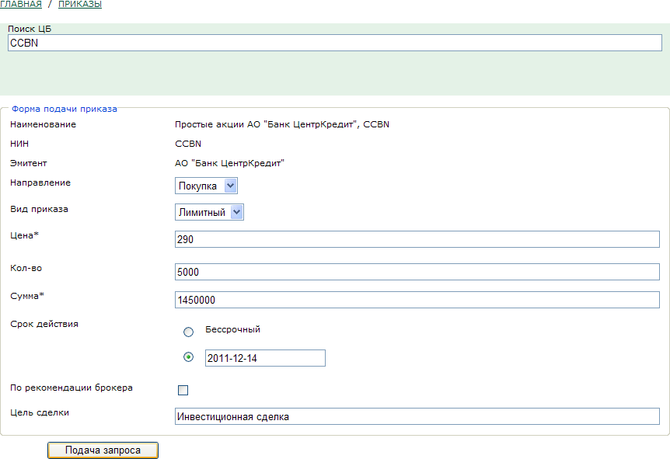

Figure 13: Filing an order (the graphical example in the Russian language).

26

8. After clicking on the “Submit Request” button, you will be redirected to the page “Order book”, where your order (command) should appear with a status of “Draft/Pending signature”. Orders (Commands) with the status “Draft/Pending Signature” can be edited and deleted. To display the order (command) in the Broker's system, the order (command) should be signed via EDS or authorized with a one-time password.

9. To send the order (command) to the Broker signed with EDS you need to sign it, for this purpose click on the button “Sign” opposite the order (command). As a result of clicking on this button you will see a document generated on the basis of the information you have entered. Carefully familiarize yourself with the text of this document, at the next stage your EDS will be put on this document.

The orders (commands) that require the use of EDS are subject to the following additional processing:

10. If the result of checking this document is positive, click on the button “Sign and send to the

Broker”. Clicking on this button will launch “Ak Kamal e-Security Client” application with

a proposal to sign the specified data:

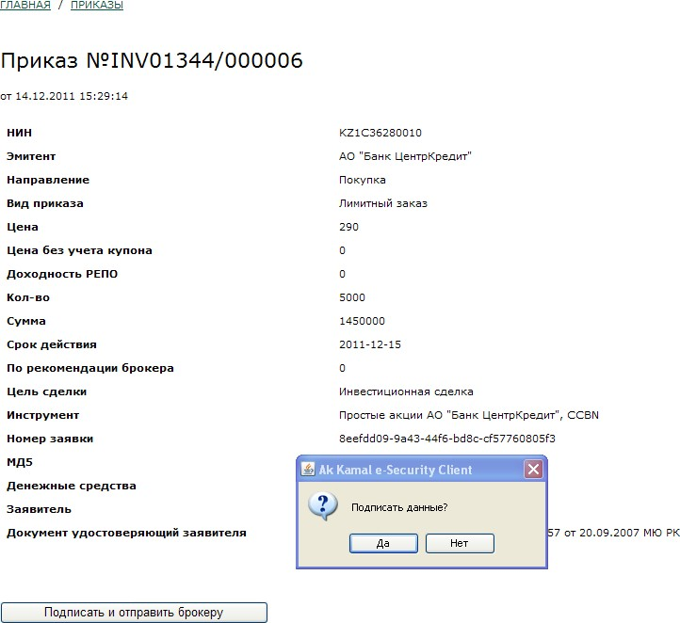

Figure 14: Forming a document for signature (the graphical example in the Russian language).

27

If the answer to this question is positive, a window with a request to enter the password to the EDS will appear:

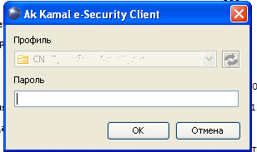

Figure 15: Entering the EDS password (the graphical example in the Russian language).

If the password is successfully verified, the order (command) will be encrypted, signed by your signature and sent to the Broker for processing. Be careful, the sent signed order (command) cannot be modified, deleted or canceled. A pending order (command) or a partially executed order (command) can be canceled only by submitting a new corresponding order (command) to cancel the previous one.

To authorize an order (command) with a one-time password, the user should follow the link “Submit to the Broker” (Figure 16), the user's cellular number will receive a text message with a password and a text with the order (command) parameters.

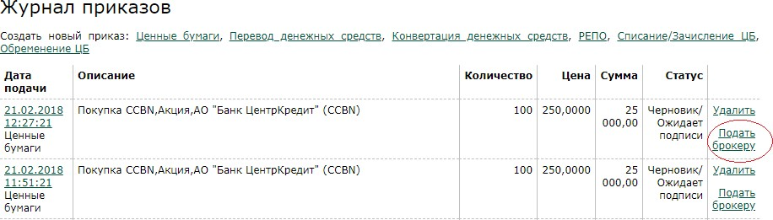

Figure 16. Signing an order (command) using a one-time password

(the graphical example in the Russian language).

After the user clicks on the “Submit to the Broker” link, a new page will open with order (command) parameters and entering a one-time password (Figure 17). The user should enter the one-time password within a minute, and click on the “Confirm and send to the Broker” button. The process of submitting an order (command) with a one-time password to the Broker's trading platform is complete.

28

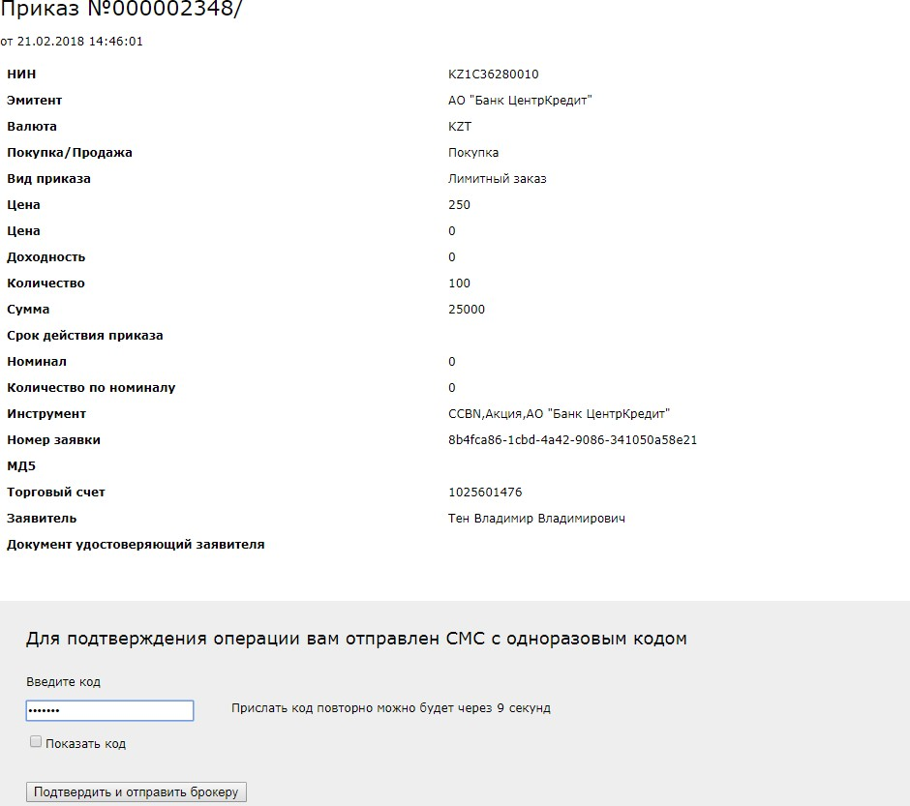

Figure 17: Entering a one-time password (the graphical example in the Russian language).

According to the requirements of the legislation and internal documents, the Broker will check the parameters of the order (command), and if successful, the order (command) will be sent for execution.

If the order (command) cannot be carried out (incomplete completion of details, signs of manipulation, etc.), the order (command) will change its status to “Rejected” with the reason for rejection. To find out the details of the reasons for refusal, please contact your manager.

In case of expiration of the order (command) before its full execution, the order (command) status may take the following values: “Partially executed” / “Unsatisfied”.

If you specified a bond, when selecting an instrument, you need to fill in one of the fields: “Price excluding coupon” or “Yield”.

The order (command) submission procedure in the application for smartphones or in the Personal Profile, when using information systems and (or) remote service systems of partners on providing access to the trading platform of the Company, may differ from the above, at the same time the principle of order (command) creation and its authorization by one-time password or by means of the Customer's EDS is also preserved.

**4.2.1. Security search procedure**

The security search procedure in the web version of the Personal Profile bcctrade.kz is based on the AJAX technology, which allows you to view the request in interactive mode without reloading the page.

29

The search for a security in the Personal Profile is performed according to the following parameters:

• Ticker - a unified code of a security assigned by the stock exchange, where the security is listed

• NSIN - Security Identification Number.

• Issuer - The company issuing the security • Name - full name of the security

You can search for a word as a whole or for a fragment of a word, but you should enter at least 3 characters in the search field.

To search, enter the fragment of the security you are looking for into the search line, after entering the 3rd character, a list of securities containing the entered keyword is automatically generated.

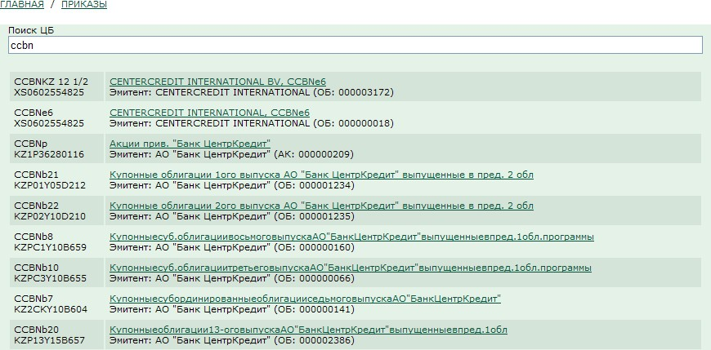

Figure 18. Security search (the graphical example in the Russian language).

To select the required security from the list, click on the name of the corresponding security.

If the above list is too large to search for the desired security, enter additional keyword characters to limit the possible variants of the securities presented, or try to rearrange the query (search by NSIN or full ticker symbol, etc.).

To facilitate the search for a security, the drop-down list of securities matching the query conditions contains the following information:

• Ticker of the security and NSIN of the security

In case you have not found the security you are interested in through this search, try to rearrange your request, if this does not lead to the desired result contact your manager to add the desired security to the specified list.

• Name of the security and name of the issuer

30

**4.2.2 Procedure for filling in the price parameters of the order (command)**

The procedure for filling in the price parameters is different for Shares and Bonds, and may also differ depending on the type of order (command): limit or market. Possible combinations of orders (commands) are discussed below:

1. Limit order (command) for transactions with shares.

In this order (command) type you will be asked to fill in the price and quantity of financial instruments. The transaction amount will be calculated automatically.

2. Limit order (command) for the transactions in bonds.

In this type of order (command) you will be offered a choice of filling in the price, you can specify the price without coupon (“Net price”) or the yield of the transaction, then you should specify the number of financial instruments. In this case the transaction amount cannot be calculated automatically, as it depends on the accrued coupon, which can be calculated only at the moment of the transaction execution.

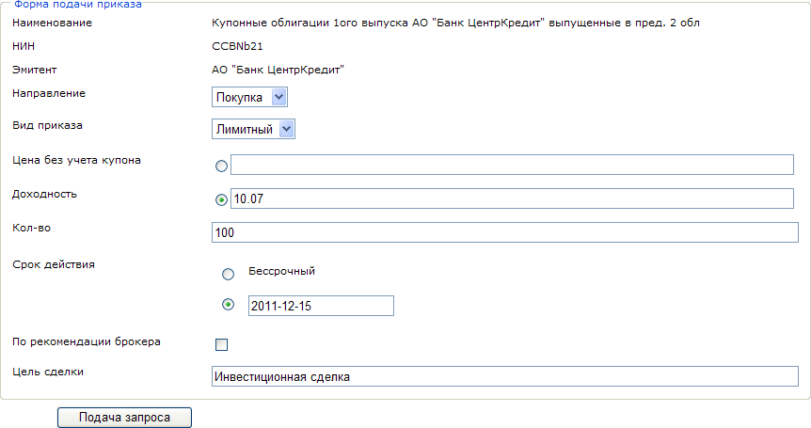

Figure 19: Filing of an order. Bonds. (the graphical example in the Russian language).

3. Market order (command) for transactions in shares and transactions in bonds

In this type of order (command) you cannot specify a price, the order (command) will be executed automatically by the “best” market price available at the moment the Broker sends the order (command) for execution. In case of a buy trade the amount field shall be filled in, in case of a sell trade the quantity field shall be filled in.

31

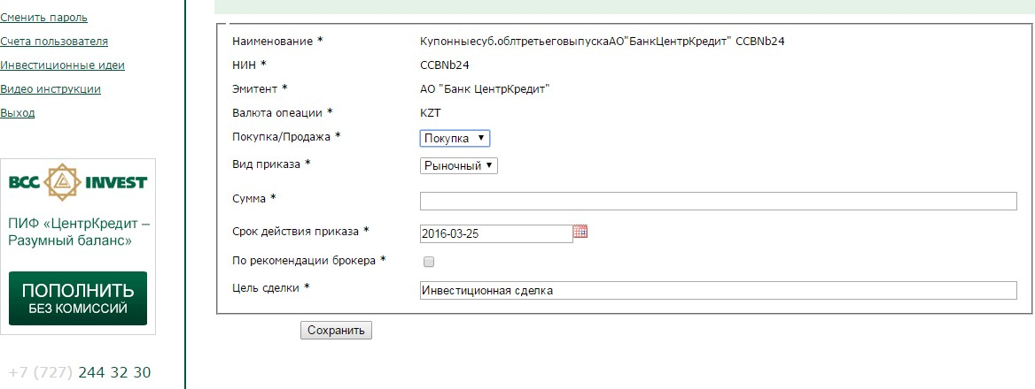

Figure 20: Submission of a buy order (command). Market. (the graphical example in the Russian language).

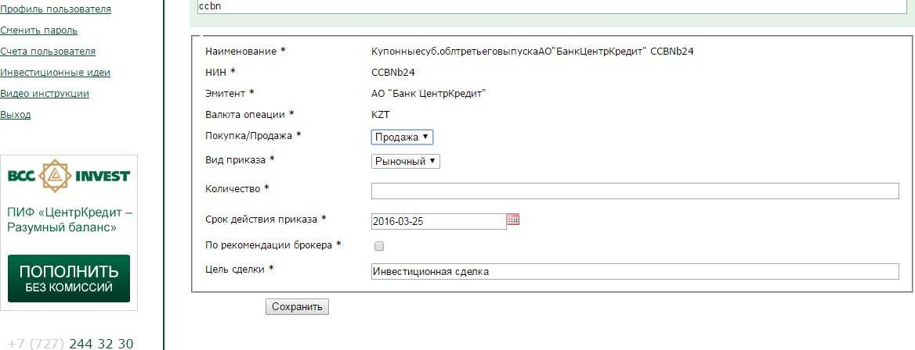

Figure 21: Submitting a sell order (command). Market. (the graphical example in the Russian language).

32

**4.2.3 Validity period of the order (command)**

In this part of the order (command) you can specify the date on which the order (command) is valid. To do this, click in the date field and a calendar window will open, in which you can specify the required date:

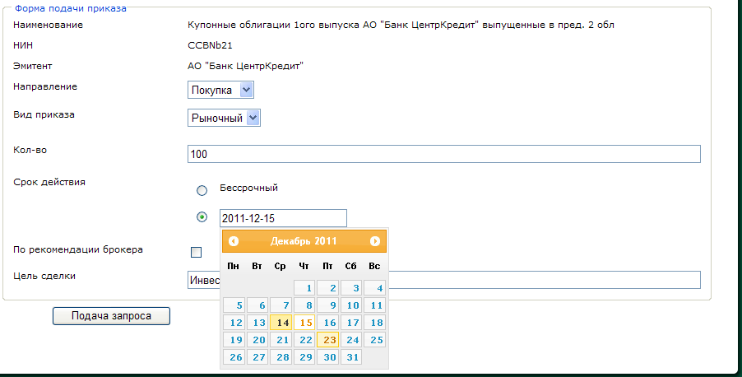Figure 22. Specifying the order (command) validity period. (the graphical example in the Russian language).

Do not enter the date from the keyboard, it may cause incorrect date entry and as a consequence the Broker's refusal to accept the order (command).

Maximum term of the order (command) is 30 calendar days for transactions at KASE. For transactions on the international market 1 trading day.

You can also submit an order (command) without specifying its validity period (in this case the order (command) validity period will be equal to 1 trading day).

In the Personal Profile of applications for smartphones or when using information systems and (or) remote service systems of partners on providing access to the trading platform of the Company may be available some types of orders (commands), as well as indication of the order (command) validity period. If necessary, use the web version of the Personal Profile of the Customer bcctrade.kz.

**4.3. Order Monetary funds**

In order to create a monetary funds transfer order (command) you should create a new order (command) in the work area of the order book by clicking on the “Monetary Funds Transfer” link.

To file an order (command), the following sequence of steps should be followed:

1. In the Payment details section specify currency, amount, value date (desired transaction date), Beneficiary code, Payment Purpose Code (PPC).

2. In the recipient section there is an option to add pre-filled details, see Section 6.2, or to re-fill the recipient details.

3. In case the monetary funds transfer is made in foreign currency, it is necessary to specify the currency transfer, further filling in additional payment details.

4. Press the “Save” button.

33

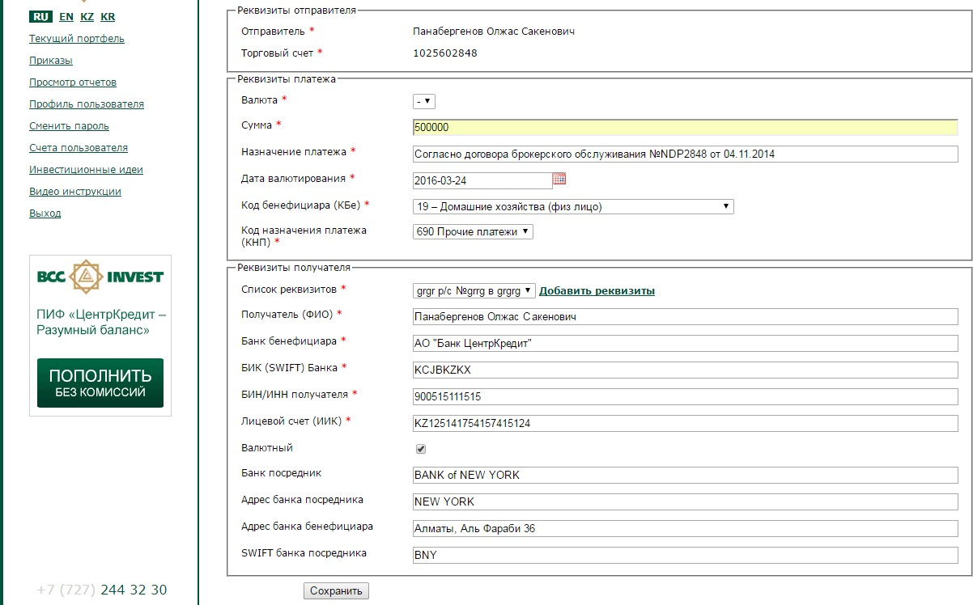

Figure 23. Creating an order to transfer funds. (the graphical example in the Russian language).

5. After clicking on the “Save” button, you will be redirected to the page “Order book”, where your order (command) should appear with a status of “Draft/Pending signature”. Orders (Commands) with the status “Draft/Pending Signature” can be edited and deleted.

6. To send the order (command) to the Broker authorized by means of EDS you need to sign it, for this purpose click on the button “Sign the Order” opposite the order (command). As a result of pressing this button you will see a document generated on the basis of the information you have entered. Carefully familiarize yourself with the text of this document, it is this document that will be signed at the next stage.

7. In case of positive result of checking this document, click on the button “Sign and send to the Broker”. Clicking on this button will launch “Ak Kamal e-Security Client” application with a proposal to sign the specified data:

34

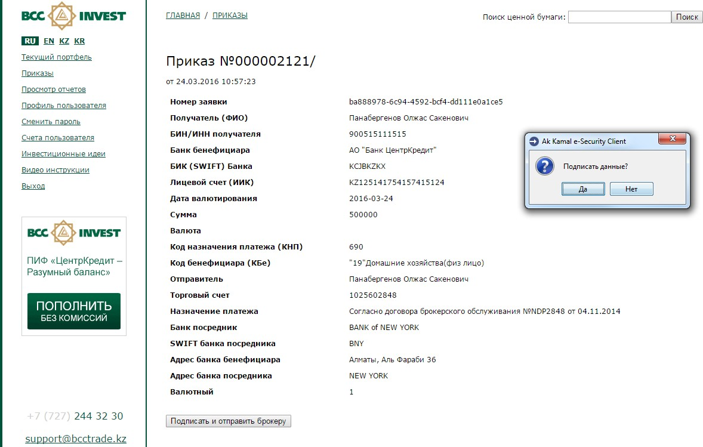

Figure 24. Formation of the document for signature (the graphical example in the Russian language).

If the answer to this question is positive, a window with a request to enter the password to the EDS will appear:

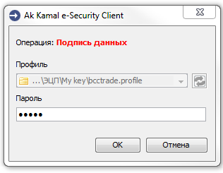

Figure 25. Entering the EDS password. (the graphical example in the Russian language).

8. To authorize the order to transfer monetary funds with a one-time password, the User should go to the “Order book” page, select from the list the order (command) to be sent to the Broker for execution, and follow the link “Submit to the Broker”.

The user's cellular phone number will receive a sms with a password and a text with the order (command) parameters.

35

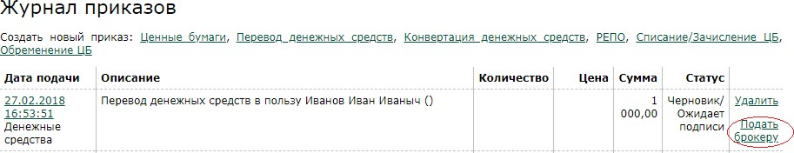

Figure 26. Authorization of the order using one-time password

(the graphical example in the Russian language).

9. After the user clicks on the “Submit to the Broker” link, a new page with order parameters and entering a one-time password will open. The user should enter the one-time password within one minute and click on the “Confirm and send to the Broker” button. The process of the order (command) submission to the Broker's trading platform is completed.

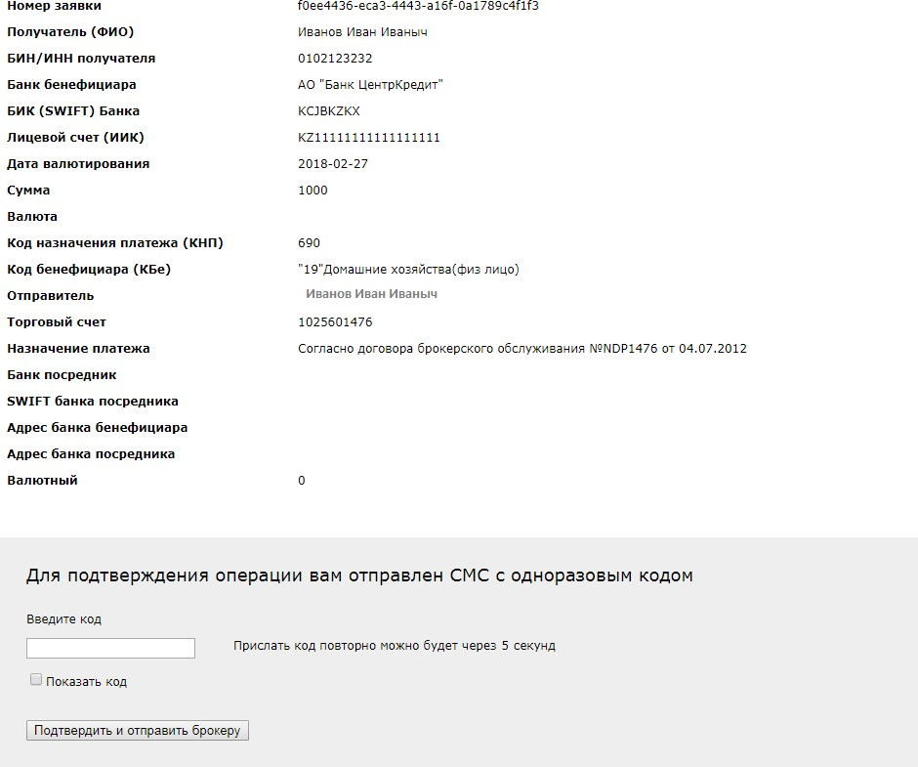

Figure 27: Entering a one-time password. (the graphical example in the Russian language).

36

10. According to the requirements of the legislation and internal documents, the Broker will check the parameters of the order (command), in case of successful passing of which the order (command) will be sent for execution.

11. In case of impossibility to execute the order (command) (incomplete filling in of details, insufficient funds, etc.) the order (command) will change its status to “The Broker's refusal” with indication of the reason for refusal. To find out the details of the reasons for refusal, please contact your manager.

**4.4. Order Monetary Funds Conversion**

In order to create the monetary funds conversion order, you should create a new order (command) in the work area of the order book by clicking on the “Monetary Funds Conversion” link.

To file the order (command), the following sequence of steps should be followed:

1. Specify the currency of sale and purchase.

2. Specify the amount of the sale or the amount of the purchase.

3. Specify the value date (the desired date of the transaction).

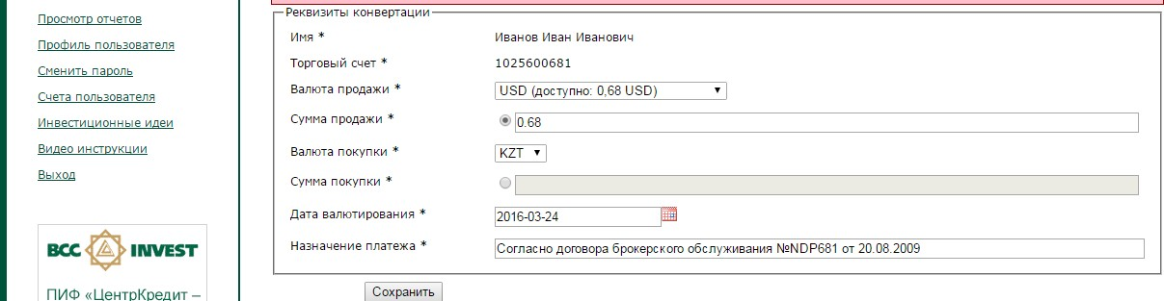

Figure 28. Formation of an order for monetary funds conversion

(the graphical example in the Russian language).

4. Click the “Save” button.

5. After clicking on the “Save” button, you will be redirected to the page “order book”, similar to the “securities” order (command), where your order (command) should appear with the status “Draft/Pending Signature”. The orders (commands) with the status of “Draft/Pending Signature”, can be edited and deleted.

6. To send the order (command) to the Broker signed with EDS you need to sign it, for this purpose click on the button “Sign the Order” opposite the order (command). As a result of pressing this button you will see a document generated on the basis of the entered information.

Carefully familiarize yourself with the text of this document, at the next stage your EDS will be affixed on this document. In case of positive result of checking this document, click on the button “Sign and send to the Broker”. As a result of clicking on this button the application “Ak Kamal e-Security Client” will be launched with a proposal to sign the specified data.

7. To send an order (command) to the Broker, authorized with a one-time password, the user should go to the “Order book” page, select from the list the order (command) to be sent for execution to the Broker, and follow the “Submit to the Broker” link.

The user's cellular phone number will receive a sms with a password and a text with the order (command) parameters.

After the user clicks on the “Submit to the Broker” link, a new page will open with order (command) parameters and entering a one-time password. The user should enter the one-time password within one minute, and click on the button “Confirm and send to the Broker”. The process of submitting the order (command) with a one-time password to the Broker's trading platform is complete.

37

The order (command) submission procedure in the application for smartphones or in the Personal Profile, when using information systems and (or) remote service systems of partners on providing access to the trading platform of the Company, may differ from the above, at the same time the principle of order (command) creation and its authorization by one-time password or by means of the Customer's EDS is also preserved.

Monetary funds conversions are made at the custodian bank's exchange rate.

**4.5. The REPO order (command)**

In order to create an order (command) to Raise/Replace the monetary funds, you should create a new order (command) in the work area of the Order book by clicking on the “Repo” link.

To file the order, the following sequence of steps should be followed:

1. Specify purchase/sale (Raise /Locate the monetary funds).

2. Specify collateral (The REPO Instrument).

3. Specify the REPO rate in %.

4. Specify the amount, when raising the monetary funds or the amount, when

placing the monetary funds.

5. Specify the Subject of the REPO, when raising the monetary funds.

6. The REPO term appears automatically, when the collateral is specified (The Repo Instrument).

7. The expiration date of the order (command) is always specified for one day.

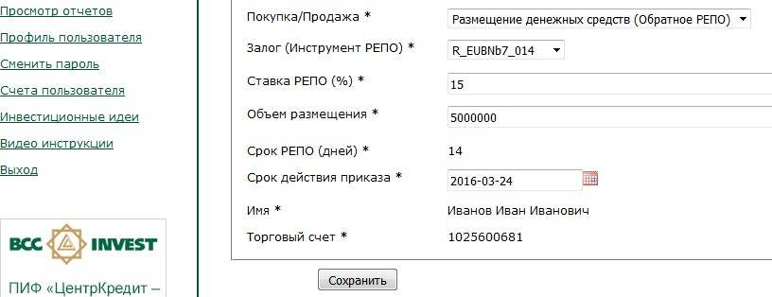

Figure 29. Order (Command) for placement of the monetary funds

(the graphical example in the Russian language).

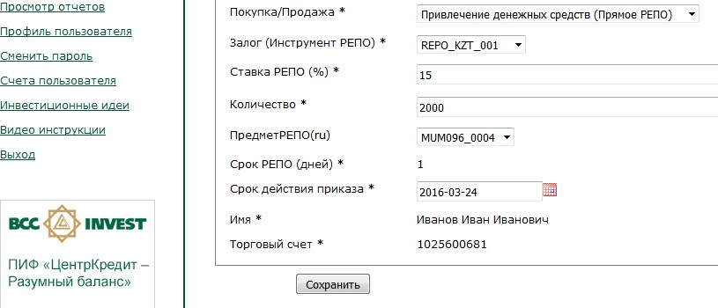

Figure 30. Order (Command) to raise the monetary funds

(the graphical example in the Russian language).

38

8. Press the “Save” button.

9. After clicking on the “Save” button, you will be redirected to the page “Order book”, similar to the “securities” order (command), where your order (command) should appear with the status “Draft/Pending Signature”. The orders (commands) with the status “Draft/Pending Signature”, can be edited and deleted.

10. To send the order (command) to the Broker signed with EDS you need to sign it, for this purpose click on the button “Sign the Order” opposite the order (command). As a result of pressing this button you will see a document generated on the basis of the information you have entered. Carefully familiarize yourself with the text of this document, at the next stage your EDS will be put on this document. In case of positive result of checking this document, click on the button “Sign and send to the Broker”. As a result of clicking on this button the application “Ak Kamal e-Security Client” will be launched with a proposal to sign the specified data.

11. To send the order to the Broker authorized with a one-time password, the user should go to the “Order book” page, select from the list the order (command) to be sent for execution to the Broker, and follow the “Submit to the Broker” link.

The user's cellular phone number will receive a sms with a password (4-digit code values) and a text with the order (command) parameters.

After the user clicks on the “Submit to the Broker” link, a new page will open with order (command) parameters and entering a one-time password. The user should enter the one-time password within a minute, and click on the button “Confirm and send to the Broker”. The process of submitting the order (command) with a one-time password to the Broker's trading platform is complete.

The order (command) submission procedure in the application for smartphones or in the Personal Profile, when using information systems and (or) remote service systems of partners on providing access to the trading platform of the Company, may differ from the above, at the same time the principle of the order (command) creation and its authorization by one-time password or by means of the Customer's EDS is also preserved.

39

**4.6. Order Writing off/Crediting of Securities**

In order to create the order for Writing off/Crediting of Securities, you should create a new order (command) in the work area of the Order book by clicking on the link “Writing off/Crediting of Securities”.

To file the order, the following sequence of steps should be followed:

1. In the securities search line, select the appropriate security with which the transaction is planned to be executed. For more details on the security selection see Section 5.1.1.

2. In the transaction line, select one of the transaction types.

3. In the trading account line specify the counterparty's trading account. 4. Specify the Individual Identification Number/Business Identification Number of the counterparty.

5. Specify the name of the counterparty.

6. Select the counterparty's brokerage company.

7. Specify the price and quantity of the security.

8. The field denomination and quantity by denomination is filled in automatically.

9. Press the “Save” button.

10. After clicking on the “Save” button, you will be redirected to the page “Order book”, similar to the “securities” order (command), where your order (command) should appear with the status “Draft/Pending Signature”. The orders (commands) with the status of “Draft/Pending Signature”, can be edited and deleted.

11. To send the order (command) to the Broker signed with EDS you need to sign it, for this purpose click on the button “Sign order” opposite the order (command). As a result of pressing this button you will see a document generated on the basis of the information you have entered. Carefully familiarize yourself with the text of this document, at the next stage your EDS will be affixed on this document.

12. In case of positive result of checking this document, click on the button “Sign and send to the Broker”. Clicking on this button will launch “Ak Kamal e-Security Client” application with a proposal to sign the specified data.

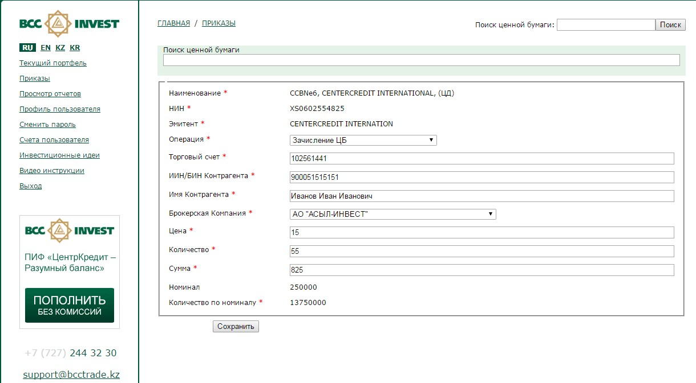

Figure 31. Creation of the order for writing off/crediting of securities

(the graphical example in the Russian language).

40

The order (command) submission procedure in the application for smartphones or in the Personal Profile, when using information systems and (or) remote service systems of partners on providing access to the trading platform of the Company, may differ from the above, at the same time the principle of the order (command) creation and its authorization by one-time password or by means of the Customer's EDS is also preserved.

**4.7 The order Securities Encumbrance.**

In order to create an order (command) for Securities Encumbrance, you should create a new order (command) in the work area of the Order book by clicking on the Securities Encumbrance link.

To file the order (command), the following sequence of steps should be followed:

1. In the securities search line, select the appropriate security with which the transaction is planned to be executed. For more details on security selection see Section 5.1.1.

2. In the transaction line, select one of the transaction types.

3. In the trading account line specify the counterparty's trading account. 4. Specify the Individual Identification Number/Business Identification Number of the counterparty.

5. Specify the name of the counterparty.

6. Select the counterparty's brokerage company.

7. Specify the price of securities (this field is optional). 8. Specify the quantity of securities.

9. The field denomination and quantity by denomination is filled in automatically.

10. Press the “Save” button.

11. After clicking on the “Save” button, you will be redirected to the page “Order book”, similar to the “securities” order (command), where your order (command) should appear with the status “Draft/Pending Signature”. The orders (commands) with the status of “Draft/Pending Signature”, can be edited and deleted.

12. To send the order (command) to the broker signed with EDS you need to sign it, for this purpose click on the button “Sign the Order” opposite the order (command). As a result of pressing this button you will see a document generated on the basis of the information you have entered. Carefully familiarize yourself with the text of this document, at the next stage your EDS will be put on this document.

13. In case of positive result of checking this document, click on the button “Sign and send to the Broker”. Clicking on this button will launch “Ak Kamal e-Security Client” application with a proposal to sign the specified data.

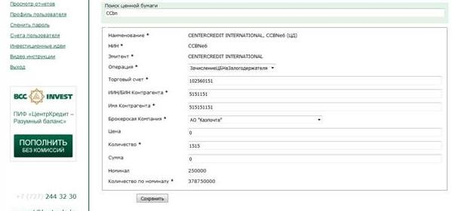

Figure 32. Creating the order for Securities Encumbrance

(the graphical example in the Russian language).

41

The order (command) submission procedure in the application for smartphones or in the Personal Profile, when using information systems and (or) remote service systems of partners on providing access to the trading platform of the Company, may differ from the above, at the same time the principle of the order (command) creation and its authorization by one-time password or by means of the Customer's EDS is also preserved.

**5. SERVICE**

A number of service functions are available for your convenience: **5.1. List of securities**

This section is used to view the list of securities allowed for trading through the Personal Profile, to view the quotation schedule for these securities.

**5.2. User Accounts**

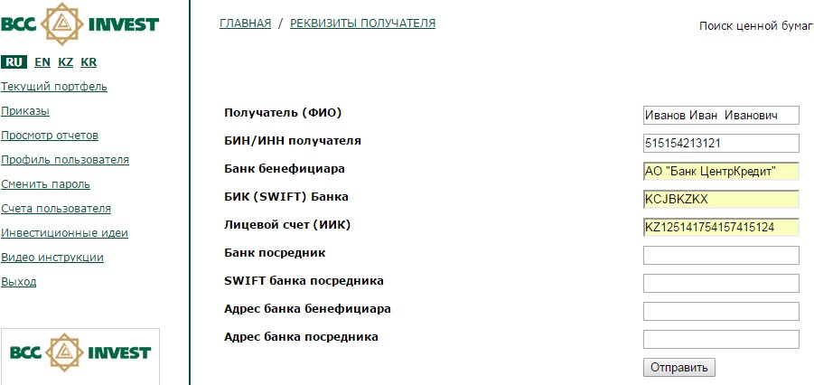**In this section you can add details for transfer of the monetary funds**

Figure 33. Recipient details

(the graphical example in the Russian language).

**5.3.** **The password change**

To change the password you should use this mode and specify: current password, new password and to confirm enter the new password again, then press the “Send request” button.

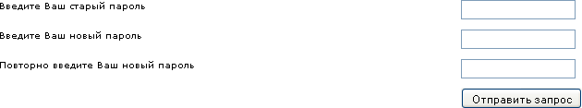

Figure 34. Change of the password (the graphical example in the Russian language).

42

**5.4. User Profile** This section serves to:

We remind you that you can work in your Personal Profile with only one active certificate.

1.to view the list of initialized EDS, as well as to activate/deactivate your EDS in the system.

After sending a request to add a new certificate, wait until it has been verified by the company manager

and assigned the **“Active”** status.

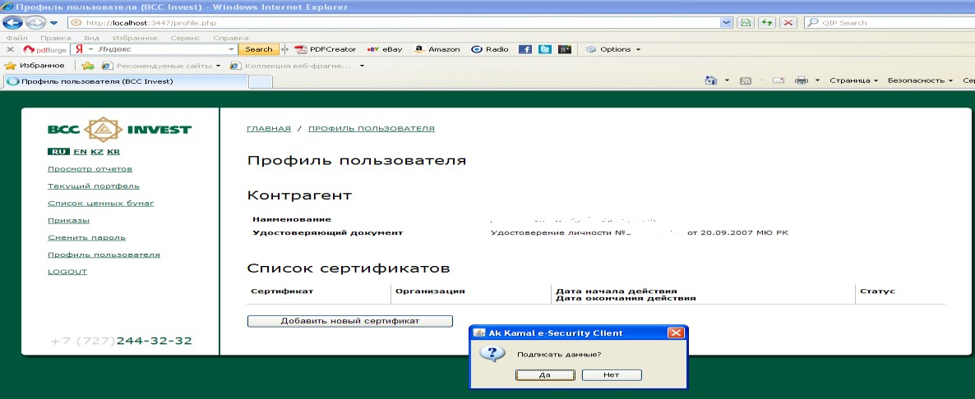

Figure 35. EDS activation (the graphical example in the Russian language).

2. view the Agreement on Provision of Electronic Services.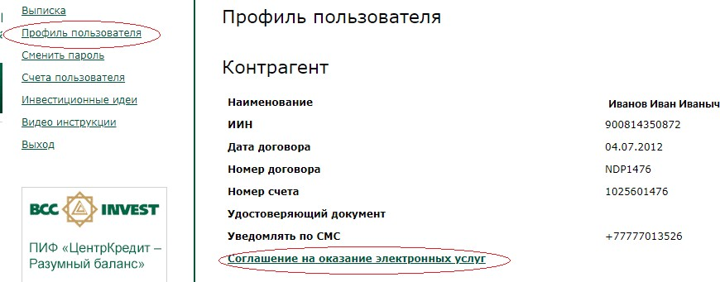

Figure 36. Agreement on Provision of Electronic Services (the graphical example in the Russian language).

3. view limits on the transactions available for authorization with a one-time password.

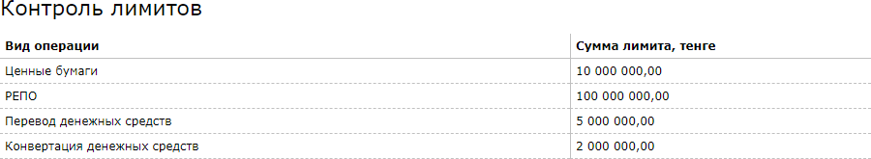

Figure 37. Transaction limits (the graphical example in the Russian language).

43

**Recommendations for information security compliance:**

**Dear Customer, we kindly ask you to pay attention to the recommendations listed below. Your compliance with the minimum conditions of information security is the key to ensuring the protection of your personal data.**

1) Please, do not write down your password information. If you have created a password record, make sure that only you have access to it!

2) Please, store your EDS in a location that is protected from unauthorized access;

3) If you have a suspicion of unauthorized access to a personal document or use of EDS without your knowledge, immediately contact your manager at “BCC Invest” JSC to block the service;

4) We recommend changing your password at least once a month. For maximum efficiency, the password should consist of 8 to 14 characters, using Latin letters, special characters and numbers.

5) Install an antivirus program on your computer, and if possible, update the antivirus database at least once every two days. Also check your computer for viruses at least once a week. This will increase your security against Trojan viruses and spyware, which collect information about the user's computer and can copy the password from the keyboard.

6) “BCC Invest” JSC never contacts customers by e-mail or otherwise to request any data on accounts, passwords or other personal information of customers. You should delete any received messages requesting the personal information or containing a link to a questionable Web-page, where you are asked to enter these data. Such messages are fraudulent.

Therefore, please, do not respond to emails and messages requesting your confidential information.

44